Exercise Manual

for

Acceleration Stack for Intel® Xeon® CPU with FPGAs Workshop

Software Requirements

CentOS 7.4 Linux* OS
Intel® Quartus® Prime Pro software version 17.1.1 with Arria® 10 family
Acceleration Stack for Intel® Xeon® CPU with FPGA 1.1
ModelSim SE 10.5c

Exercise 1

Creating a Host Application
In this exercise, you will practice writing a host application that will leverage the OPAE API to discover the FPGA Accelerator, gain access to it, setup the memory to communicate with it, and write the configuration registers to configure it and start it computing.

If you have difficulty with any of the tasks in this exercise, please consult the instructor.

Tips for working in the VM:
- The VM will resize along with the window it is in. It gains this capability after you log in.
- Tab completes a filename if there is no ambiguity in the match of the characters you have already typed. Double-clicking tab will show you a list of possibilities.
- The command pwd will show the directory you are currently in.
- You can open a visual diff tool by typing tkdiff.
- If you prefer gvim or emacs instead of gedit, they are installed.

Step 1. Setup Virtual Machine Lab Environment
- Login to remote laptop using Password: QPrime.1
- In Windows* Explorer, navigate to the flash drive
- Go into the Acceleration_VM directory
- Double click on Acceleration_VM_1.1.vbox
This should start Oracle VM VirtualBox and boot the machine.
If the VM did not boot automatically, try removing but NOT deleting the existing machines inside VirtualBox and add the .vbox file on the flash drive and start the VM.
- Log into the VM as User:Student Password: QPrime.1
All further instructions will assume you are operating within the Linux VM unless noted otherwise.
- Open a terminal
  - ApplicationsSystem ToolsTerminal or right click on background and select Open terminal
- Navigate to the workshop directory and open lab files
  - Type “cd fpga_trn”
  - If there is an AccelStack_Workshop directory, delete it using “rm -rf AccelStack_Workshop”
  - Untar the lab files my typing “tar -xvf AccelStack_Workshop.tar .”

Step 2. Examine Host Code
- Open application source code
  - Type “cd AccelStack_Workshop/hello_afu/sw”
  - Type “gedit hello_afu.c” in the terminal

- Scroll down to #include section (line 27) and examine the included libraries for OPAE

- Scroll down to #defines section (line 42) and examine the constants defined for things like the AFU ID and the SCRATCH REGISTER value that will be used to pass data between the Host and the FPGA accelerator (simple example)

- Scroll down to line 59 and examine the error handling functions that will be used if any step of the setup of the accelerator fails

- Scroll down to main (line 92) and examine the variables being defined.

Notice the fpga_properties object, token and handle that will be used to enumerate the accelerator.

- Look for the comment “1.1 Create properties object” and examine the fpgaGetProperties() API command directly after it.

Passing a NULL in the token field creates an empty properties object, pointed to by the filter variable we defined earlier, so that it will match all FPGA resources in the enumeration query. We will refine the search criteria in the next step.

- Look for the comment “1.2 Refine search criteria of properties object” and examine the next lines of code.

We are further refining the search criteria of the filter properties object to look for the object type FPGA_ACCELERATOR with the GUID we defined earlier. The fpgaPropertiesSet*() API allows setting specific fields in the fpga_properties object

- Look for the comment “1.3 Create a token” and examine the next line of code.
Now we need to search the PCIe space for the FPGA resource in the system that matches the filtered fpga_properties object criteria we defined and create the accelerator token for it when found. We do this with the fpga_Enumerate() API.

It is possible that the number of matches could be more than 1, so this case we are defining the max number of tokens to accept to be 1. Otherwise, the API takes whatever is smaller between max_tokens and num_matches. If the system returns 0, we need to delete the properties object and throw and error.

- Look for the comment “1.4 Refine search criteria of properties object” and examine the next lines of code.

We now request ownership of the FPGA resource referenced by the token in order to interact with it. We use the fpgaOpen() API to do this.

- Look for the comment “1.5 Map FPGA Accelerator register space into user space” and examine the next lines of code.

We now provide access to control registers in the accelerator to access through MMIO transactions. This returns the mmio_ptr to a specified MMIO space of the target object in process virtual memory. Since we defined this to be NULL implies access will be performed through fpgaReadMMIO*() and fpgaWriteMMIO*() APIs.

- Look for the comment “1.6 Reset Accelerator” and examine the next lines of code.

Here we are resetting the FPGA accelerator we just got ownership of with the appropriate handle.

- Look for the comment “1.7 Access Mandatory AFU Registers” and examine the next lines of code.

Here we read the MMIO configuration registers that are part of the device feature header using the 64bit read API. We read the data from the respective fields in the header file and print the values to the screen.

- Look for the comment “1.8 Access AFU User Scratch-Pad Register” and examine the next lines of code.

In this simple AFU example, we simply read and write the scratch register to show simple data transfers between the host and the accelerator displaying the initial value and then showing that we have updated the register with a new value. This is needed for configuration accesses. For actual data movement between host and accelerator, DMAs are used and would complicate learning OPAE with understanding DMA configuration. As a follow-on, refer to the 2 DMA sample designs to showcase how to move blocks of data over to the FPGA to be processed automatically vs here with configuration reads and writes.

Step 3. Compile the Host code
- Close the gedit window and return to the terminal window
- Open the Makefile file
  - Type “gedit Makefile”
This file contains the gcc command lines to compile the host code. When creating your own application, make sure to start with this makefile and modify as needed.
- Close the gedit window and return to the terminal window
- Compile the host application
  - Type “make hello_afu”
This should take a split second and you should see the executable for the Lab1 excersize in the directory.. We can’t currently run the code because we don’t have the system setup with a PAC board in it to use. In later labs we will simulate the AFU with the host code and see it working without hardware.
- In the terminal window, type “ls” to see the compiled Lab1 executable that is now present.

Exercise Summary

- Practice writing Host code that communicates with an FPGA accelerator using the OPAE layer.

END OF EXERCISE 1

---------------------------------------------------------------------------------------------
Intel Corporation. All rights reserved.

Intel, the Intel logo, Altera, Arria, Cyclone, Enpirion, MAX, Nios, Quartus and Stratix words and logos are trademarks of Intel Corporation or its subsidiaries in the U.S. and/or other countries.

Intel warrants performance of its FPGA and semiconductor products to current specifications in accordance with Intel's standard warranty, but reserves the right to make changes to any products and services at any time without notice. Intel assumes no responsibility or liability arising out of the application or use of any information, product, or service described herein except as expressly agreed to in writing by Intel. Intel customers are advised to obtain the latest version of device specifications before relying on any published information and before placing orders for products or services.
*Other names and brands may be claimed as the property of others.

Exercise 2

Simulating with ASE

Step 1. Examine RTL Code
- Go to hello_afu rtl directory
  - Type “cd ~/fpga_trn/AccelStack_Workshop/hello_afu/hw/rtl”
- Examine RTL directory structure and files
  - Type “ls”
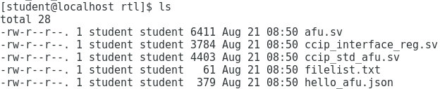
This will show the main files used in the AFU including the AFU source file, and also the CCI interface files that the AFU connects to and finally the .json file containing the metadata for the AFU.
  - Type “more filelist.txt” to examine the files listed text file for the project
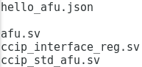
  - Type “gedit afu.sv” to open the AFU file.
Here you can see a simple AFU with basic scratch registers that can be read to or written to from the host program

  - Type “ls $OPAE_PLATFORM_ROOT/hw/samples/dma_afu/hw/rtl” to see the a more robust sample design using the BBB blocks

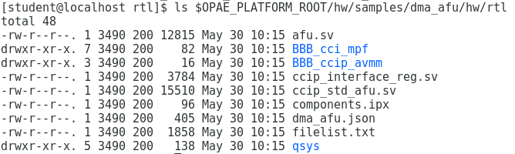

Compare the .json, the afu.sv and the filelist.txt files and see how the more elaborate AFU looks.
Step 2. Simulate the AFU with the host program
- Close the gedit window and return to the terminal.
- Navigate to back to top level project directory and build the ASE environment.
  - Type “cd ~/fpga_trn/AccelStack_Workshop/hello_afu”
  - Type “afu_sim_setup –source hw/rtl/filelist.txt build_sim”
This creates a directory named build_sim with the necessary files needed to run the simulation of the rtl code as part of the ASE environment.
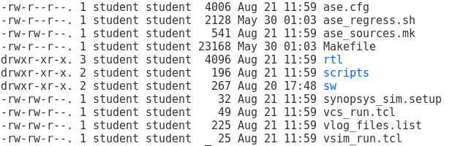
- Run the simulator
  - Type “cd build_sim”
  - Type “make”
  - Type “make sim”
These scripts setup the particular simulation environment, compiles the RTL code for simulation and loads the simulation. This is the hardware simulator server window which is now waiting for the stimulus from the host application code which will act as the testbench as shown in this diagram below.

Note: Given the project that we are simulating, the output reminds you to set the appropriate ASE_WORKDIR environment variable in the ASE client window and the appropriate command is provided. We will use that in the next steps.
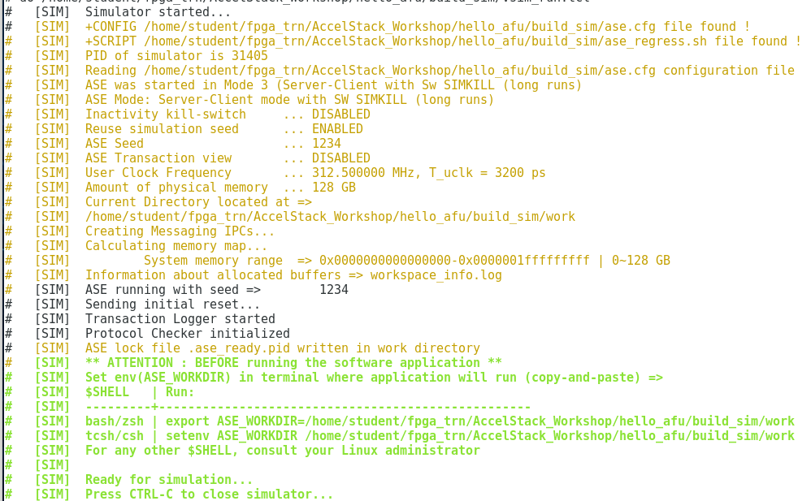
- Open a second terminal window. Right click on background and select Open Terminal.
- In the second terminal window, set the ASE working directory environment variable.
  - Highlight the export command for the bash shell in the server window (first window)
  - Right-click and select copy
  - In the 2nd terminal window, right-click and select paste followed by pressing the Enter key
We just as easily could have added this environment variable to our bash shell.
- Compile the host application as the client process
  - Type “cd ~/fpga_trn/AccelStack_Workshop/hello_afu/sw”
  - Make clean
  - Make USE_ASE=1
  - ./hello_afu
This compiles and runs the host application code, but links against the simulation libraries rather than the OPAE runtime libraries. This client process running the software communicates with the simulator inline and without the need for hardware. It also will validate the OPAE communication with the AFU. IN this simple example you can see the MMIO Reads and Writes taking place between the hardware and software components.
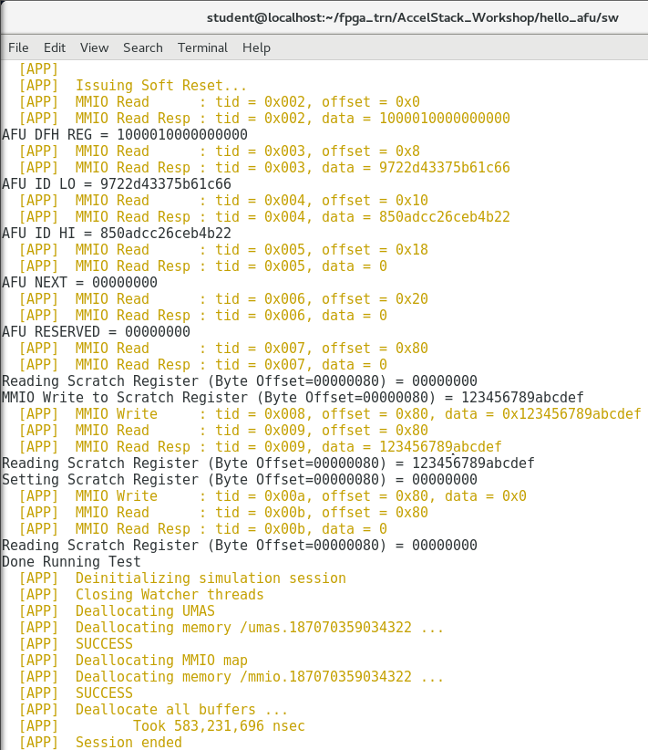
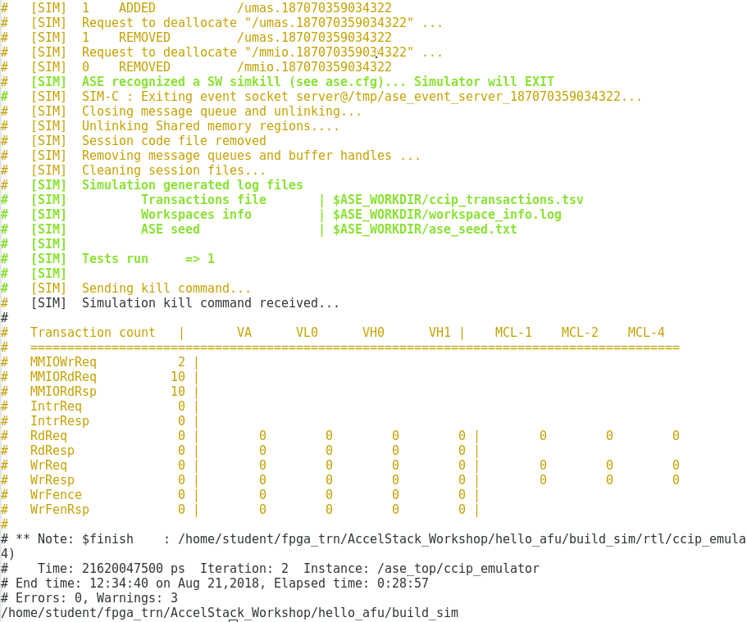
Step 3. Compile the AFU
- In either terminal window, type “cd ~/fpga_trn/AccelStack_Workshop/hello_afu”
- Generate the Accelerator Function build environment
  - Type “afu_synth_setup –source hw/rtl/filelist.txt build_synth”
This creates a build_synth directory with the projects build subdirectory directory containing all the files needed to build the PR region of the FPGA to turn the AFU into an AF .gbs file.
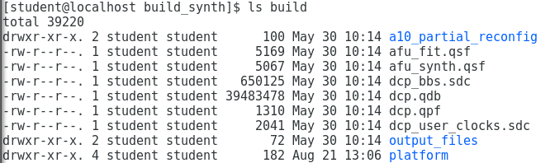
- Generate the Accelerator Function
  - Type “cd build_synth”
  - Type “$OPAE_PLATFORM_ROOT/bin/run.sh”
This script handles running the compile through the Quartus Prime software and producing the Green Bits Stream to be loaded onto a PAC card. This typically takes a long time (>45 minutes) so, get it started or just use the solution directory going forward. Once completed you will be able to open Quartus with the project file that gets created and review the timing reports, placement reports, netlist viewer, …etc.

Exercise Summary

- Ran scripts to perform a cosimulation of host application code with AFU
- Ran script to build GBS for FPGA

END OF EXERCISE 2

---------------------------------------------------------------------------------------------
Intel Corporation. All rights reserved.

Intel, the Intel logo, Altera, Arria, Cyclone, Enpirion, MAX, Nios, Quartus and Stratix words and logos are trademarks of Intel Corporation or its subsidiaries in the U.S. and/or other countries.

Intel warrants performance of its FPGA and semiconductor products to current specifications in accordance with Intel's standard warranty, but reserves the right to make changes to any products and services at any time without notice. Intel assumes no responsibility or liability arising out of the application or use of any information, product, or service described herein except as expressly agreed to in writing by Intel. Intel customers are advised to obtain the latest version of device specifications before relying on any published information and before placing orders for products or services.
*Other names and brands may be claimed as the property of others.

Exercise 3

Add a Scratch Register to AFU and Host Application

Step 1. Customize the AFU and host application
- In ~/fpga_trn/AccelStack_workshop/hello_afu/hw/rtl directory modify the afu.sv file
- In ~/fpga_trn/AccelStack_workshop/hello_afu/sw directory modify the hello_afu file
- Run ASE to validate new AFU using setup_sim.sh and run_app.sh scripts
- Try debugging AFU with Signal Tap. Refer to documentation online for more details.

